Multiple-choice section – choose the correct answer

Question 1 [5.1]

The perimeter of a square of side length  cm is:

A 25.36 cm B 27 cm C 24 cm D 25 cm

Question 2 [5.3]

A circle of radius cm has a circumference correct to 2 decimal places, of:

A 63.22 cm B 126.44 cm C 63.24 cm D 126.45 cm

Question 3 [5.3]

A semi-circular protractor of radius  cm has a perimeter correct to 2 decimal places, of:

A 53.99cm B 32.99 cm C 107.97 cm D 65.98 cm

Question 4 [5.4]

A parallelogram of area 42 cm2 and height 8 cm has a base length of:

A 4.25 cm B 5.25 cm C 5 cm D 6 cm

Question 5 [5.4]

A trapezium has an area of 518 cm2. If its parallel sides are 17 cm and 20 cm long, its height is:

A 12 cm B 24 cm C 28 cm D 30 cm

Question 6 [5.5]

A circle with an area of  cm2 has a radius correct to 2 decimal places, of:

A 6.76 cm B 13.53 cm C 3.68 cm D 6.52 cm

Question 7 [5.6]

The total area of a shape formed by joining a circle with radius 10 cm to   
an 11 cm by 7 cm rectangle is:

A 391.2 cm2 B 108.4 cm2 C 216.8 cm2 D 177 cm2

Question 8 [5.3]

$\sqrt{144}-3^{2}×(1-3)$ The area of the triangle, in square centimetres, is:

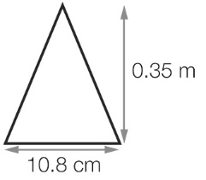

A 1.89 B 189 C 378 D 3.78

Question 9 [5.7]

The volume of a rectangular prism with height 0.6 m, width 0.5 m and length 80 cm is:

A 24 m3 B 2.4 m3 C 0.24 m3 D 240 000 m3

Question 10 [5.8]

Alana started a marathon at 10:42 am and finished two and a half hours after midday on the same day. The time that she took was:

A 3 hours 54 minutes B 3 hours 48 minutes C 3 hours 6 minutes D 3 hours 24 minutes

Multiple-choice results: ___ / 10

Short answer section

Question 11 2 marks [5.1]

Find the perimeter of the rectangle in mm.

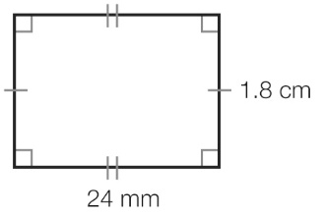

Question 12 2 marks [5.1]

Find the perimeter of the shape in mm.

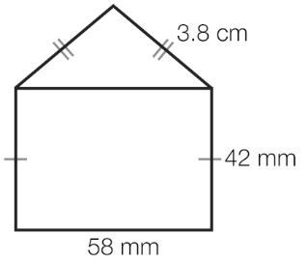

Question 13 2 marks [5.1]

Find the perimeter of a regular hexagon with edge length cm.

Question 14 5 marks [5.1]

Find the perimeter of the following shapes.

(a)   
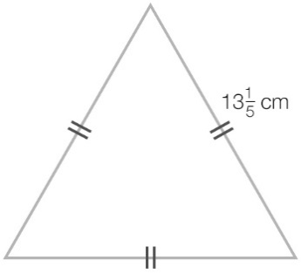

(b)  
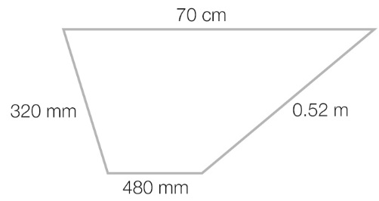

(c)  
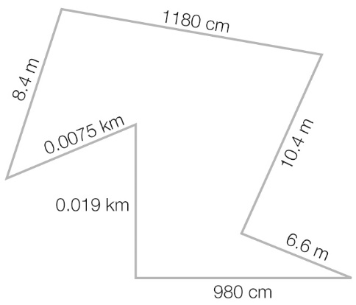

Question 15 3 marks [5.2]

The circumference of a circle with radius of 15 cm is 94.25 cm2. Find the ratio of   
the circumference of the circle to the diameter of the circle and state the symbol used for that ratio.

Question 16 4 marks [5.3]

The radius of the circular track shown below is 200 m.

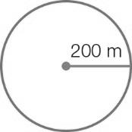

(a) Find the distance around this track, to the nearest km.

(b) Find the area enclosed by this track.

Question 17 2 marks [5.4]

Find the area of a parallelogram which has a base length of  cm and a height of  cm.

Question 18 2 marks [5.4]

Find the area of the trapezium.

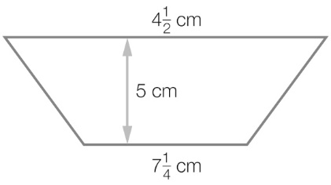

Question 19 5 marks [5.4]

Find the area of the following shapes.

(a)   
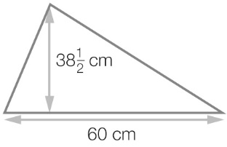

(b)   
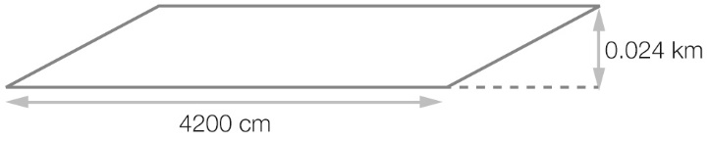

Question 20 2 marks [5.5]

Find the area of the circle.

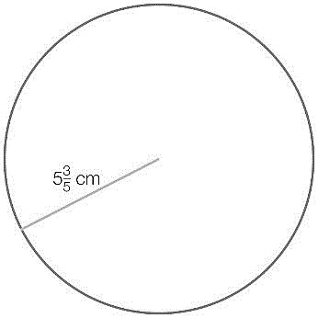

Question 21 3 marks [5.5]

Find the area of this shape correct to 2 decimal places.

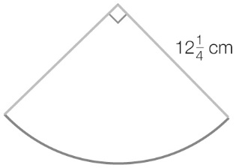

Question 22 4 marks [5.4, 5.5]

Oscar has a cake recipe that says to use a 30 cm diameter round cake tin, but he only has rectangular tins. He has a 30 cm by 25 cm tin and a square 27 cm tin.

Which one should he use? Show all working.

Question 23 3 marks [5.6]

Find the area of the following figure.

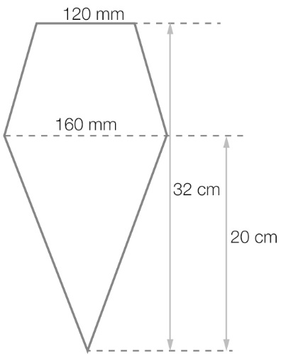

Question 24 6 marks [5.6]

Find the area of the following figures, in m2.

(a)

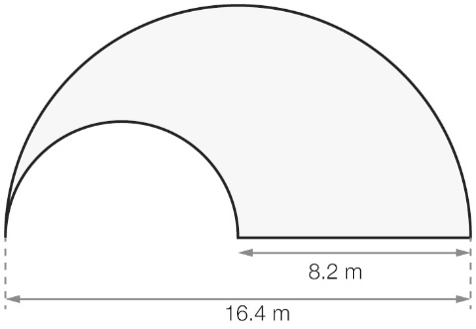

(b)

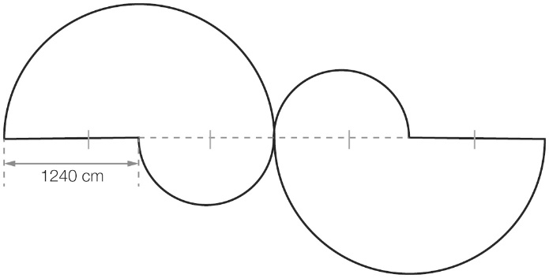

Question 25 3 marks [5.8]

What time is it  hours before:

(a) 6:21 am

(b) 10:01 pm

(c) 3:13 pm

Short answer results: ___ / 48

Extended answer section

Question 26 5 marks [5.6]

A model for an arrow to be used as a road sign is shown below.

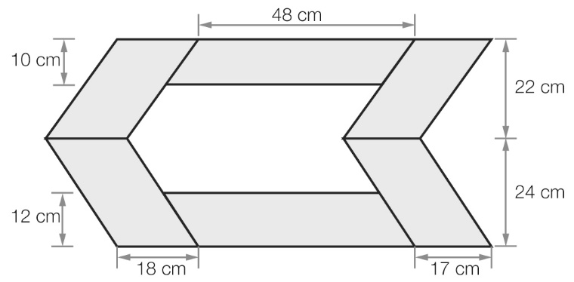

(a) The shaded area is made up of six parallelograms with dimensions as given. What area of material is needed to construct this section of the arrow?

(b) The inner section of the arrow (white) is made up of two other parallelograms. What area of material is needed to construct this part of the arrow?

Question 27 6 marks [5.7]

When it is spread out flat, a sleeping bag is 60 cm by 120 cm by 5 cm thick. It is stored in a tube that is 28 cm in diameter and 55 cm deep.

(a) Calculate the volume of the sleeping bag.

(b) Calculate the volume of the tube.

(c) Will the sleeping bag roll up to fit into the tube?

(d) State the capacity of the tube to the nearest millilitre.

Question 28 5 marks [5.8]

Imogen arrived at school at 7:22 am after taking a 32-minute tram ride from home. The first lesson started 31 minutes after she arrived at school. Recess followed the first three lessons, each of which lasted for 47 minutes. Recess lasted 24 minutes. Two lessons, each of 48 minutes, followed recess and then it was lunch time. Use the information to find:

(a) the time that Imogen caught the tram to get to school

(b) the time that recess started

(c) the time that lunch started.

Question 29 7 marks [5.7]

David is constructing a swimming pool which, when viewed from above, appears as shown in the diagram.

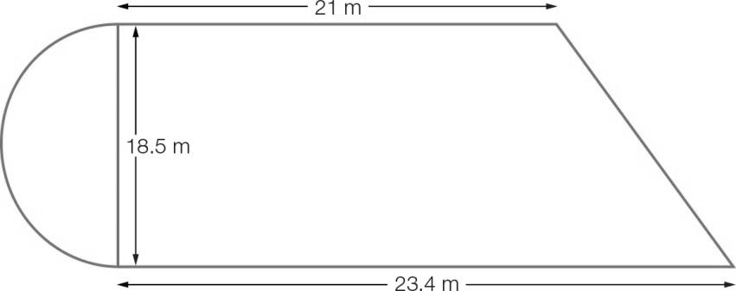

(a) Find the total volume of the swimming pool if the depth of the semi-circular region is 8.5 m and the depth of the rest of the swimming is 12 m. Round your answer to 2 decimal places

(b) How many litres of water will David need if he fills the swimming pool to ¾ of its depth?

Extended answer results: ___ /23

TOTAL test results: ___ / 81